**Major Project Report**

**Topic:**

E – learning Website called “E-Volve” using HTML, CSS and JavaScript

**Tools Used:**

Used Notepad++ to edit HTML, CSS, JavaScript documents.

**File Names:**

* eLearn.html and eLearnDesign.css
* enroll.html and enrollDesign.css
* about.html and aboutDesign.css
* dashboard.html and dashboardDesign.css
* signup.html and signupDesign.css
* Other support files include app.js and particle.js (for particle effect)

**HTML Tags Used:**

<html> <head>

<title> <link>

<body> <section>

<div> <button>

<ul> <li>

<a> <iframe>

<i> <form>

<label> <input>

<script> <nav>

<p> <h1>

<h2> <h3>

<h4> <img>

<header>

**CSS Properties Used:**

Color

Line-height

Font-family

Margin (-top, -left, -right, -bottom)

Padding (-top, -left, -right, -bottom)

Background (-color, -image, -attachment, -position, -size)

Height

Width

Text (-transform, -align, -shadow, -decoration)

Position

Letter-spacing

Border (-radius)

Min-height

Display

Content

Font-weight

Pattern

Float

Justify-contents

Align-items

z-index

overflow

box-shadow

transition

clear

**Techniques used:**

Parallax Effect:

Parallax effect is when the website layout sees the background of the web page moving at a slower rate to the foreground, creating a 3D effect as you scroll. Here the background images stay fixed while the text above it moves.

Text Reveal:

Text reveal animation is used to show enrolment over the sites. The text over a period of time reveals the number of students, courses and teachers involved.

Particle Effect:

Particle effect is used in background which seems like hexagons (particle) floating behind sign up forms. It’s done with help of particle.js and app.js.

Iframe Usage:

Iframe is used to used in dashboard.html to display sample lesson videos for a course.



Responsive Navigation bar:

Here responsive nav bar is used to navigate through various webpages of the site. Whenever hovering over navigation elements, it’s background colour changes, which shows smooth transition.



Icons Implementation:

Font Awesome 4 icons are used to give users some design to the webpages. Here, it is used to display social media through which users can follow and its also used in sidebar of dashboard.

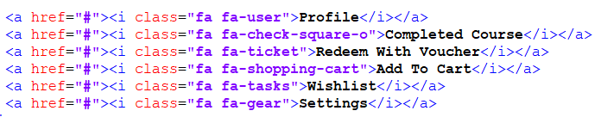



Glowing Border Effect:

Border is made to glow using a combination of linear gradient, :before :after properties, and the content.

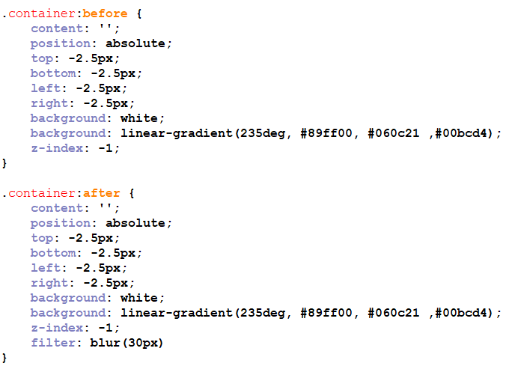

**Conclusion:**

With this number of features through using html, CSS and JavaScript, a small amount of dynamic nature is added to the website. With help of higher levels of coding with JavaScript, the website can be made more dynamic and more attractive. With extensive use of combinations of CSS, HTML and JavaScript, this site can be hosted and will serve better on recognitions.